
KULLIYYAH OF ENGINEERING

MCTA 3203: MECHATRONICS SYSTEM INTEGRATION

WEEK 2: DIGITAL LOGIC DESIGN

SECTION 2 GROUP 4

INSTRUCTOR : ZULKIFLI BIN ZAINAL ABIDIN & WAHJU SEDIONO

Date of Submission: 11th March 2026
NO | NAME | MATRIC NUMBER
1 | Hannah Irdeena binti Azrulhafiz | 2410018
2 | Azzam Azhari Noureldein Elamin | 1827295
3 | Kamarul Zafri bin Kamarul Ariffin | 2323189

ABSTRACT
This module focuses on the integration of a common cathode 7-segment display with an Arduino Uno microcontroller using two push buttons. The main objective was to design a circuit and develop code to display a numbering sequence controlled by manual inputs, whereby one input is for incrementing the displayed number from 0 to 9 sequentially and another for resetting the count to 0.
By using a breadboard, current-limiting resistors for safety and pushbuttons, a system was constructed to increment and reset a numerical count. The methodology involved mapping digital pins to specific display segments and utilizing pull-up resistors for stable button logic. The result demonstrated a successful sequential display from 0 to 9, confirming the effectiveness of manual IC-based interfacing.

TABLE OF CONTENTS

NO. | TOPIC | PAGE
1. | INTRODUCTION | 4
2. | MATERIALS AND EQUIPMENT | 4
3. | EXPERIMENTAL SETUP | 5
4. | METHODOLOGY | 6
5. | DATA COLLECTION | 8
6. | DATA ANALYSIS | 9
7. | RESULTS | 10
8. | DISCUSSION | 11
9. | CONCLUSION | 12
10. | RECOMMENDATIONS | 12
11. | REFERENCES | 12
12. | APPENDICES | 13-14

INTRODUCTION
The experiment's purpose is to understand the interface of a 7-segment display with an Arduino Uno. This module focuses on designing and implementing a simple digital counter system using an Arduino Uno and a common cathode 7-segment display, where the count value increases sequentially from 0 to 9 and resets based on user input through pushbuttons.
Described by Electronics For You (2024), a 7-segment display consists of seven light-emitting diodes (LEDs) arranged in a figure-eight pattern, with each segment labeled from ‘A’ to ‘G’. By strategically activating the segments, numerical digits from 0 to 9 can be displayed. In a Common Cathode configuration, all the negative terminals (cathodes) of the segment LEDs are connected to a single common ground (GND). To illuminate a specific segment, the microcontroller must send a logic HIGH signal to the corresponding anode.
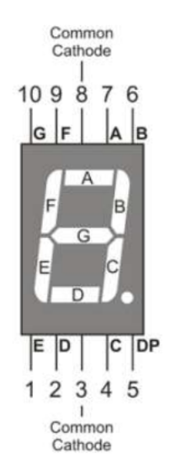
It is expected when the circuit and program is correct, the 7-segment display will show the numbers from 0 to 9 sequentially with each press of the increment button and reset to zero with the reset button. This demonstrates the key principles of signal processing, digital output control and handling with user input. This module provides a foundational understanding of digital interfacing, program control, and microcontroller-based system design, which are essential concepts for developing more complex automation and embedded systems.

MATERIALS AND EQUIPMENT
1 x Arduino Uno board
1 x Common cathode 7-segment display
7 x 220-ohm resistors
2 x Pushbuttons
Jumper wires and Breadboard

EXPERIMENTAL SETUP

- The common cathode 7-segment display was placed in the centre of the breadboard, ensuring pins were isolated across the center bridge.
- The Arduino Uno and each segment are connected with resistors.
- The common cathode pin of the display was connected directly to one of the Arduino GND pins.
- One leg of the first push button was connected to Arduino pin D7, acting as the increment button
- One leg of the second first push button was connected to Arduino pin D5, acting as the rest button
- A 10 kΩ pull-up resistor was connected to each button, with one end attached to the
corresponding digital input pin (D7 or D5) and the other end connected to the 5V line.
- The Arduino Uno was powered through a USB connection, providing both 5V and GND to the entire circuit.

METHODOLOGY
4.1 Segment connections
Digit | Segment Active | Arduino Pins (Logic HIGH)
0 | A, B, C, D, E, F | D8, D9, D12, D3, D13, D11
1 | B, C | D9, D12
2 | A, B, D, E, G | D8, D9, D3, D13, D2
3 | A, B, C, D, G | D8, D9, D12, D3, D2
4 | B, C, F, G | D9, D12, D11, D2
5 | A, C, D, F, G | D8, D12, D3, D11, D2
6 | A, C, D, E, F, G | D8, D12, D3, D13, D11, D2
7 | A, B, C | D8, D9, D12
8 | A, B, C, D, E, F, G | D8, D9, D12, D3, D13, D11, D2
9 | A, B, C, D, F, G | D8, D9, D12, D3, D11, D2
Table 1
- The table summarises the logic required to display each digit. For the setup, a logic HIGH signal must be sent to the specific Arduino pins to activate the elements.
- Ensure the resistor was placed in series with each segment to limit the current flow and prevent LED damage.
- Common anode pins of the display are tied to Arduino 5V supply.

4.2 Push-button inputs
- For each button, one leg was connected to the Arduino digital input pin and the other leg to ground (GND)
  - Increment button → D7
  - Reset button → D5

4.3 Assembly checks
- All components are assembled on a breadboard using jumper wires to make tidy connections.
- Ensure the correct pin connections and avoid loose components.

4.4 Code test
- This arduino was programmed so the system can be manually controlled sequentially from 0 to 9 using the increment button and can be set to zero using the rest button.
- Initial validation steps include: - Activating all of the segments by switching the chosen pins mode to HIGH.
- Using the serial monitor to print “button pressed” to verify whether the board is receiving the input from the push buttons.

4.5 Troubleshooting
- If a segment does not illuminate, the wiring and resistor for the segments need to be rechecked.
- All connections were rechecked after any code change to ensure hardware and software matched (pin definitions in code versus physical wiring).

DATA COLLECTION
Observations:
Button Press | Displayed Number
increment | 1
increment | 2
increment | 3
increment | 4
increment | 5
increment | 6
increment | 7
increment | 8
increment | 9
resets | 0
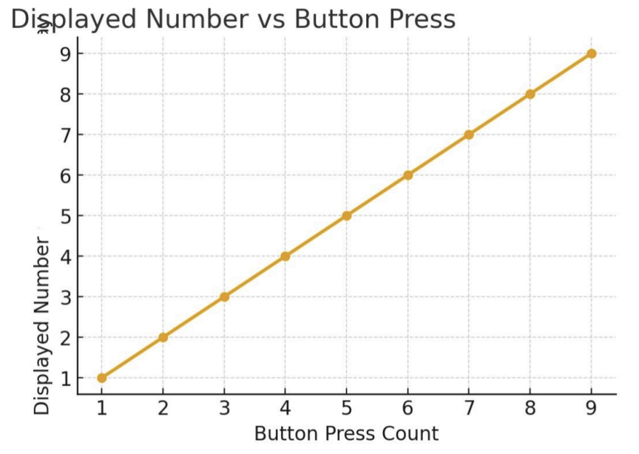

DATA ANALYSIS
From the data gathered, there is a clear correlation between the number on the 7-segment display and the number of times the button is pressed. Each time the increment button is pressed, the displayed number increases by 1, demonstrating a directly proportional relationship (Button Press=Displayed Number) until the value reaches 9. After reaching 9, the system goes back to 0 for the next increment, showing a cyclic constant behaviour.
It is also observed the system has a short delay (500ms) after every increment to avoid errors. There were also no skipped or repeated numbers during the testing. In conclusion, the counter logic works as expected and is responsive up to 9 increments.

RESULTS
The system successfully displays numbers sequentially from 0 to 9 on a 7-segment display using the increment button and was able to reset to 0 by pressing the reset button. The counter confirmed the logic and control algorithm functioned effectively.

How to Interface a 7-Segment Display with an Arduino:
- Connect Segment Pins
Connect each segments pins (A-G) to the digital output pins as follow:
- A → D8
- B → D9
- C → D12
- D → D3
- E → D13
- F → D11
- G → D2
- Add Current-Limiting Resistors and Connect Common Cathode
Insert 220Ω resistors in series with each segment connection to protect the LEDs. Add jumper wires from display common cathode pins directly to the ground (GND) of the Arduino
- Wire the Push Buttons
- Increment Button: One leg to D7 and the other to GND.
- Reset Button: One leg to D5 and the other to GND.
- Upload the Program
In Arduino IDE, upload the counter code where with every press of the increment button the numbers raise sequentially from 0 to 9 and can be reset any time with the press of the reset button.
- Verify & Troubleshoot
Observe the 7-segment displays correctly with each press of the button. Ensure debounce delays are implemented to avoid overlapping counts from a single press.
If it does not function as expected:
- Confirm the pin definition matches the wiring.
- Ensure correct button placement and orientation on the breadboard.
- If a segment does not illuminate, recheck the wiring and resistors.

DISCUSSION
Conditions | Expected Outcome | Observed Outcome
Increment Button | The displayed number increases by 1 every time the button is pressed | Worked as expected after adding some delay
Continuous Operation | Stable and correct counting from 0 to 9 | Worked as expected
Reset Button | Display resets to 0 when button is pressed | Worked as expected
7-Segment Display stability | All segment illuminates brightly with no flickering | Minor flickering due to loose wiring

Sources of Error:
- Wiring
Unstable or loose jumper wire connections on breadboard leads to incorrect segment lighting and segment flickering, affecting the stability and display errors.
- Button Bounce
The mechanical buttons cause multiple overlapping signals during a single press, which results in skipped or repeated counts. This can be minimised by adding delays.

How can you interface an I2C LCD with Arduino? Explain the coding principle behind it compared to a 7-segment display and a matrix LED.
The interaction between an I2C LCD and an Arduino system operates through Serial Communication, which enables the microcontroller to handle complex display output through a two-wire connection that uses SDA for data transmission and SCL for clock synchronization instead of needing seven connections which a standard 7-segment display requires. The coding principle of a 7-segment display operates through Direct Pin Mapping, which requires creating the complete digit by changing each individual segment from A to G. The Matrix LED uses Multiplexing as its third operational principle, which streams row and column data at high speeds to produce visual content that appears continuous due to the viewer's ability to see multiple frames of animation. The I2C LCD system allows users to send high-level commands through its library interface which includes lcd.print() while an onboard controller takes care of all detailed pixel operations, but the 7-segment display needs programmers to perform bitmasking tasks for each digit they want to display.

CONCLUSION
The system successfully achieved its primary objective of interfacing a 7-segment display with an Arduino Uno through effective hardware assembly and coding. Using Arduino to control a common cathode 7-segment display with two push buttons as a counter button and a resetter button. The Arduino was able to process the input signals and produce the correct output by displaying the numbers. Small issues of loose wiring and bounce were able to be overcome by debouncing and rechecking the wiring. Ensuring the success of a more stable and accurate system.
Overall, this project has provided a foundational understanding of how microcontrollers process digital inputs and outputs to control visual displays. The logic used in this counter has offered significant real-world applications in systems such as elevator floor indicators and electronic scoreboards. By properly assembling the circuit and uploading the correct program, the hypothesis was supported as the system displayed digits 0–9 accurately with manual control.

RECOMMENDATIONS
Improvements and modifications
The system can be improved by adding a buzzer to act as an auditory feedback to confirm that the arduino has registered the user’s input, as well as being able to use it without having to constantly stare at the LEDs to ensure that the numbers have changed.
Insights and lessons
The floating pin problem occurs when a microcontroller input is not connected to a definite voltage level resulting in a state where it oscillates between LOW and HIGH. These oscillations are subject to electromagnetic interferences. This can result in the arduino registering presses without actually physically pressing the push button that’s connected in the breadboard. To fix this a pull-up or pull-down resistor must be used.

REFERENCES

- Week 2: Digital Logic System: Basic Logic Gates, Electronic Circuit Interfacing, Basic ALU, 7-segment display, ICs based interfacing application (ver. 2).
- 7-Segment Display Pinout & Understanding. Electronics For You. Available at: https://www.electronicsforu.com/resources/7-segment-display-pinout-understanding

APPENDICES
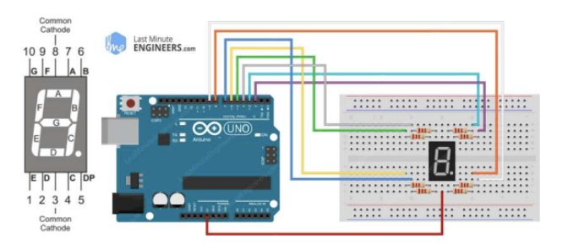

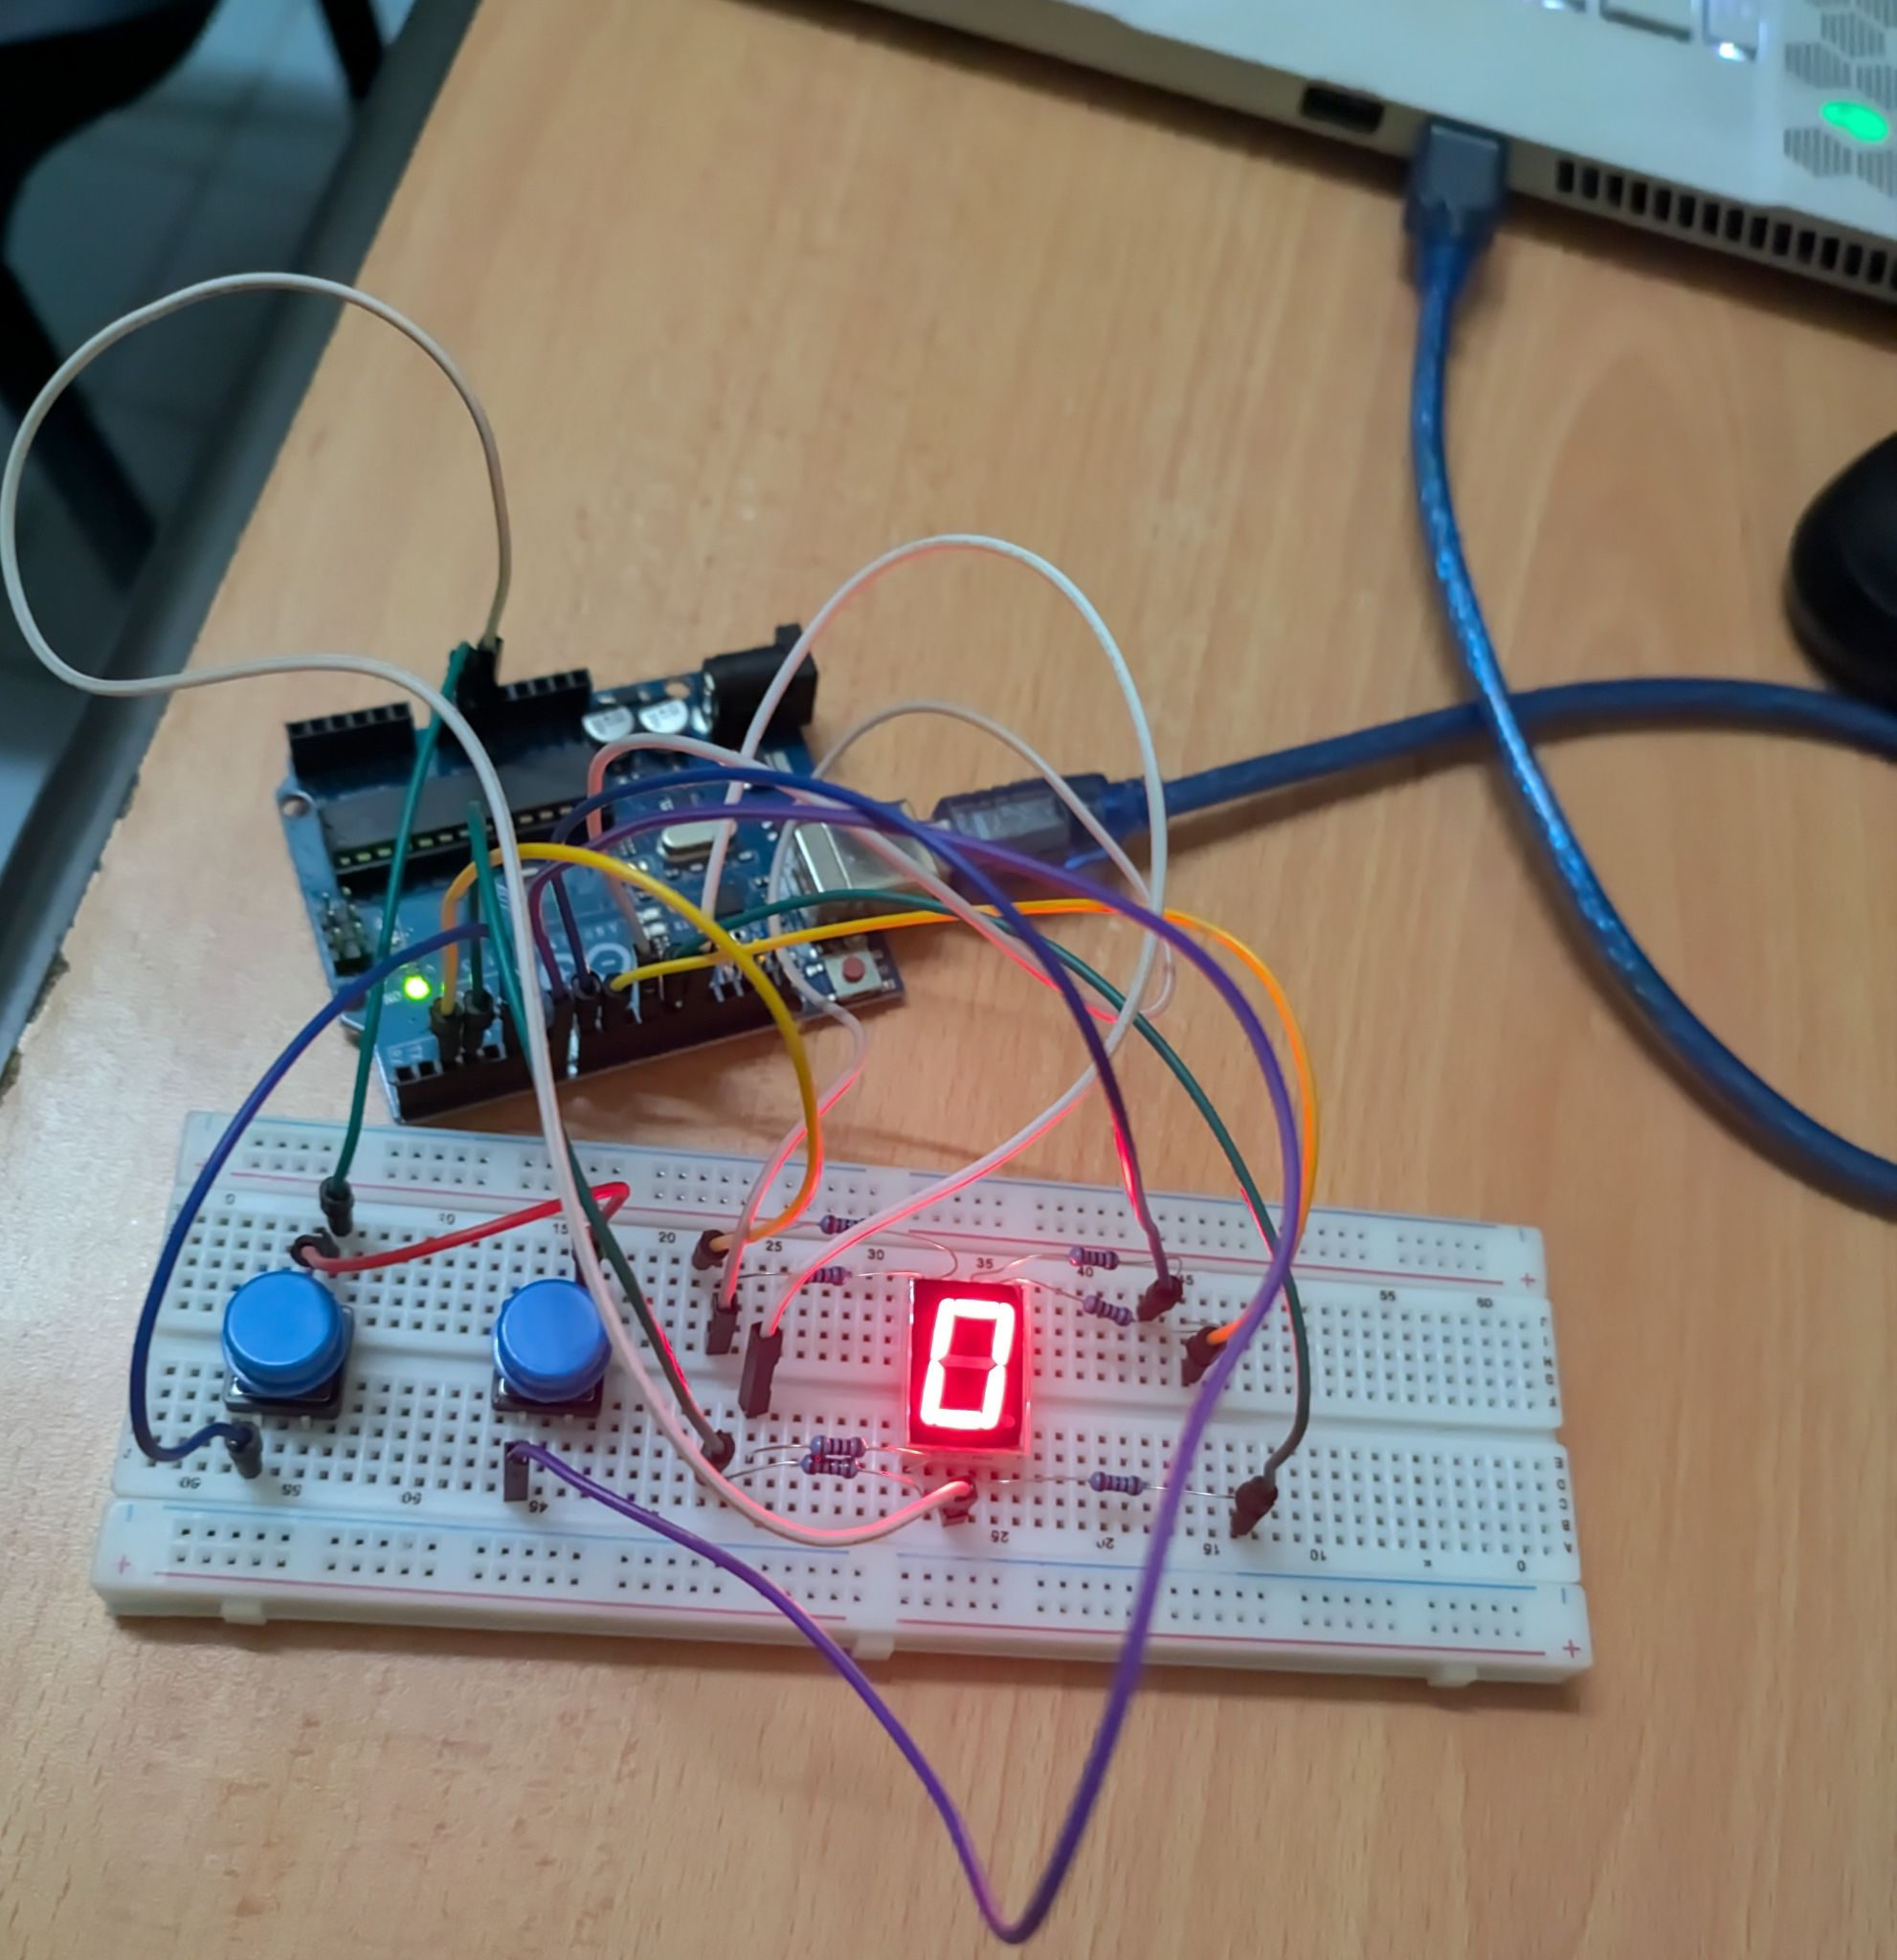

Displaying numbers have been done through a switch-case function that looks like this:
void displayNumber(int num) {
clearDisplay();

switch (num) {
case 0: // displays the number 0
digitalWrite(segmentA, HIGH); digitalWrite(segmentB, HIGH);
digitalWrite(segmentC, HIGH); digitalWrite(segmentD, HIGH);
digitalWrite(segmentE, HIGH); digitalWrite(segmentF, HIGH);
break;
case 1: // displays the number 1
digitalWrite(segmentB, HIGH); digitalWrite(segmentC, HIGH);
Break;
// etc…..

Acknowledgements:
We would like to express our sincere gratitude to Dr. Zulkifli Bin Zainal Abidin and Dr. Wahju Sediono for their continuous support and for providing the essential resources and facilities required to carry out this project. We also extend our heartfelt appreciation to everyone who contributed to the success of this lab report through their valuable insights, assistance, and feedback.

Student’s Declaration:
We hereby affirm that the work presented in this report is entirely our own. All sources used for background information and theory have been properly cited, and have strictly adhered to the principles of academic integrity throughout this report.

